**CYCLE 7**

**PROGRAM 1**

**AIM**

Write a Python program to read a file line by line and store it into a list.

**SOURCE CODE**

def read_file_into_list(filename):

with open(filename, 'r') as file:

lines = file.readlines()

return [line.strip() for line in lines]

filename = "example.txt"

lines_list = read_file_into_list(filename)

print(lines_list)

**example.txt**

this is the first line

now the second

this is third

next fourth

**OUTPUT**

**---------------------------------------------------------------------------------------------------------------**

**PROGRAM 2**

**AIM**

Python program to copy odd lines of one file to other.

**SOURCE CODE**

def copy_odd_lines(source_file, destination_file):

with open(source_file, 'r') as src:

lines = src.readlines()

with open(destination_file, 'w') as dest:

for i in range(0, len(lines), 2):

dest.write(lines[i])

source = "sample.txt"

destination = "odd_lines.txt"

copy_odd_lines(source, destination)

print("Odd lines have been copied.")

**sample.txt**

this is the first line

now the second

this is third

next fourth

**OUTPUT**

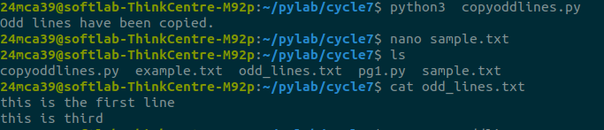**---------------------------------------------------------------------------------------------------------------**

**PROGRAM 3**

**AIM**

Write a Python program to read each row from a given csv file and print a list of

strings.

**SOURCE CODE**

import csv

def read_csv_file(filename):

with open(filename, mode='r', newline='') as file:

reader = csv.reader(file)

for row in reader:

print(row)

csv_filename = "example.csv"

read_csv_file(csv_filename)

**example.csv**

this is the first line

now the second

this is third

next fourth

**OUTPUT**

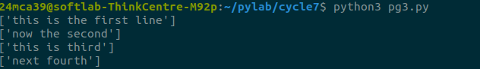

**---------------------------------------------------------------------------------------------------------------**

**PROGRAM 4**

**AIM**

Write a Python program to read specific columns of a given CSV file and print the

content of the columns.

**SOURCE CODE**

import csv

def read_specific_columns(filename, columns):

with open(filename, mode='r', newline='') as file:

reader = csv.reader(file)

for row in reader:

selected_columns = [row[i] for i in columns]

print(selected_columns)

csv_filename = "data.csv"

columns_to_read = [0, 2]

read_specific_columns(csv_filename, columns_to_read)

**data.csv**

Name, Age, City

John, 28, New York

Anna, 22, London

Peter, 34, Berlin

Maria, 25, Madrid

David, 30, Paris

**OUTPUT**

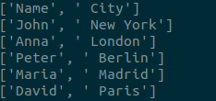

---------------------------------------------------------------------------------------------------------------

**PROGRAM 5**

**AIM**

Write a Python program to write a Python dictionary to a csv file. After writing the

CSV file, read the CSV file and display the content.

**SOURCE CODE**

import csv

def write_dict_to_csv(filename, data):

with open(filename, mode='w', newline='') as file:

writer = csv.DictWriter(file, fieldnames=data[0].keys())

writer.writeheader()

writer.writerows(data)

def read_csv_file(filename):

with open(filename, mode='r', newline='') as file:

reader = csv.DictReader(file)

for row in reader:

print(row)

dict_data = [

{'Name': 'John', 'Age': 28, 'City': 'New York'},

{'Name': 'Anna', 'Age': 22, 'City': 'London'},

{'Name': 'Peter', 'Age': 34, 'City': 'Berlin'}

]

csv_filename = "output.csv"

write_dict_to_csv(csv_filename, dict_data)

print("CSV file content:")

read_csv_file(csv_filename)

**OUTPUT**

